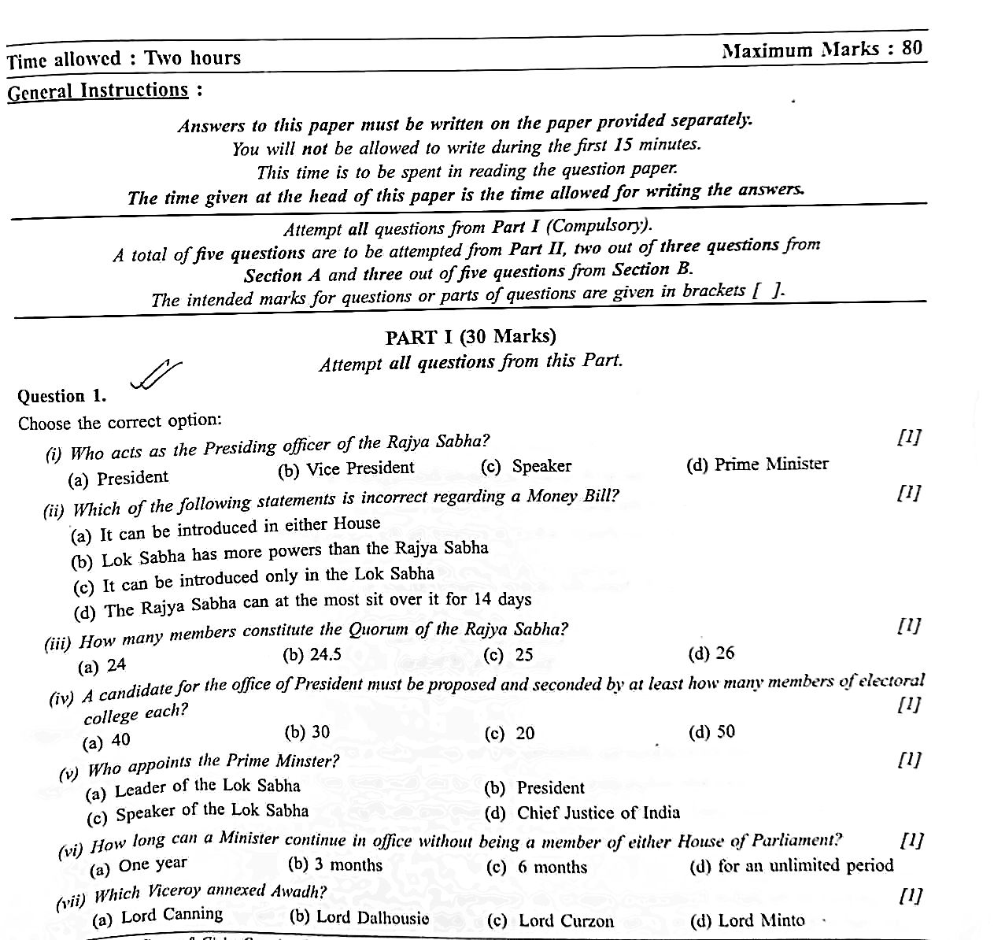

(By Subrata Sir & group of ICSE and CBSE school teachers)

GUIDELINES

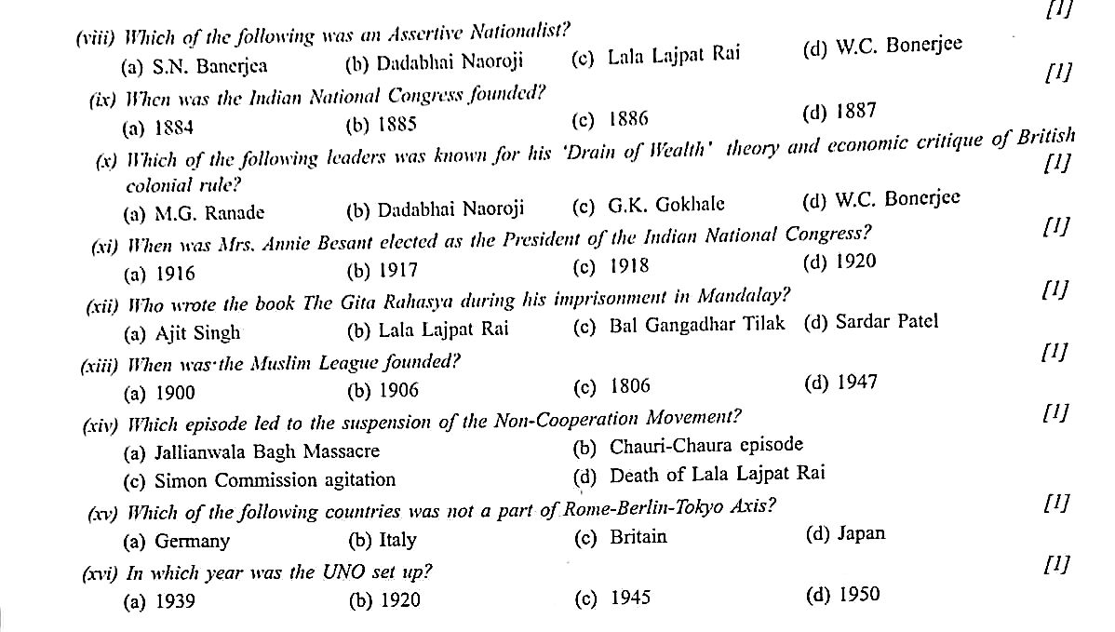

# Question (2)

1. Who solve the disputes related with President’s Election ? (2)
2. What is an Ordinances ? Mention its limitation. (2)
3. Name the highest Civil & Criminal Court in a district. (2)
4. Name 4 Architects of NAM. (2)
5. When & by whom Indian National Congress was founded ? (2)
6. Give 2 aims & objective of INA.
7. Mention the freedom struggler of quotation –
   1. “Do or Die”
   2. “Give me blood, I will give you freedom “.

# PART – II ( 50 Marks )

**Section – A ( Civics )**

# Attempt any two questions from this Section.

**Question – 3. (2+2+3+3)**

1. Explain how Lok Sabha is powerful than Rajya Sabha. ( any 2 ).
2. Explain 2 exclusive power of Rajya Sabha.
3. Define - a) Quorum b) Session c) Residuary Power
4. Explain 3 ways Parliament can control over Executive.

# Question – 4. (2+2+3+3)

1. Mention the qualification of President.
2. Give 2 reason for Indirect election of President.
3. Explain 3 Executive Power of President.
4. Explain Legislative power of President.

# Question – 5. (2+2+3+3)

1. Why Supreme Court is known as Final interpreter and Guardian of the Constitution.
2. Mention the qualification of Supreme Court Judges.
3. Explain Original Functions of Supreme Court.
4. Mention 3 advantages of Lok Adalat.

# Section – B ( History )

**Attempt any three questions from this Section.**

# Question 6 :

**(2+2+3+3)**

1. Explain the contribution of Raja Rammohan Ray.
2. Mention the aims & objectives of INC.
3. Explain 3 political causes of 1857 Revolt.
4. Explain Immediate Cause of 1857 Revolt.

# Question 7 : (2+2+3+3)

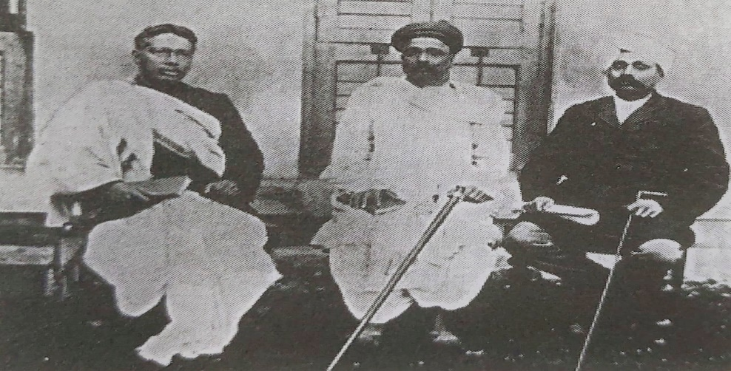

1. Name the personalities of above pictures.
2. Mention 2 real motive of Bengal Partition (1905).
3. Differentiate between Early & Assertive Nationalist in reference of Beliefs & Method.
4. Give 2 contribution of Bal Gangadhar Tilak & Bipin Chandra Pal.

# Question 8 : (2+2+3+3)

1. Explain - a) Chauri Chaura Incident

b) Dandi – March

1. What was Rowlatt Act ? Explain
2. In reference of Civil Disobedient Movement answer
   1. Gandhi - Irwin Pact
   2. Second Round Table Conference.
3. Mention 3 Contribution of INA & Subhas Chandra Bose.

# Question 9 : (2+2+3+3)

1. Name 2 groups of World War I & II
2. Mention 2 Causes of World War I ( except immediate cause )
3. Explain immediate cause of World War I & II
4. Explain 6 terms of Treaty of Versailles.

# Question – 10 : (2+2+3+3)

1. What is NAM, Mention 2 millitary alliances.
2. Name ‘Big Five’, What is Veto Power ?
3. Mention 2 function of each a) UNICEF

b) UNESCO

1. Explain the composition of General Assembly, Security Council & International Court of Justice.